A REPORT OF SIX WEEKS INDUSTRIAL TRAINING

at

INTERNITY FOUNDATION

SUBMITTED IN PARTIAL FULFILLMENT OF THE REQUIREMENT FOR THE AWARD

OF THE DEGREE OF

BACHELOR OF ENGINEERING

(Computer Science & Engineering)



MAY-JUNE, 2019

**SUBMITTED BY:**

NAME: Aniruddha M Agrawal

UID: 17BCS3264

DEPARTMENT OF COMPUTER SCIENCE & ENGINEERING

CHANDIGARH UNIVERSITY GHARUAN, MOHALI

**CONTENTS**

**Topic Page No.**

***Candidate’s Declaration 3***

***Abstract 4***

***Acknowledgement 4***

***About the Company/ Industry / Institute 5***

***Introduction 6***

***Objective 7***

***System Requirements 8***

***Design 9-17***

***Future Scope 18***

***References 19***

**CHANDIGARH UNIVERSITY, GHARUAN, MOHALI**

**CANDIDATE'S DECLARATION**

I Aniruddha M Agrawal hereby declare that I have undertaken six weeks industrial internship at INTERNITY FOUNDATION during a period from 26/May/2019 to 09/Jul/2019 in partial fulfillment of requirements for the award of degree of B.E (COMPUTER SCIENCE & ENGINEERING) at CHANDIGARH UNIVERSITY GHARUAN, MOHALI. The work which is being presented in the internship report submitted to Department of Computer Science & Engineering at CHANDIGARH UNIVERSITY GHARUAN, MOHALI is an authentic record of training work.

Signature of the Student

The six weeks industrial training Viva–Voce Examination of__________________ has been held on ____________ and accepted.

 Signature of Internal Examiner Signature of External Examiner

**ABSTRACT**

We designed an android app that harnesses the accelerometers in personal smartphones to record earthquake-shaking data for research, hazard information and warnings. The app has the function to distinguish earthquake shakings from daily human activities based on the different patterns behind the movements. It also can be triggered by the traditional earthquake early warning (EEW) system to record for a certain amount of time to collect earthquake data. When the app is triggered by the earthquake-like movements, it sends the trigger information back to our server which contains time and location of the trigger, at the same time, it stores the waveform data on local phone first, and upload to our server later. Trigger information from multiple phones will be processed in real time on the server to find the coherent signal to confirm the earthquakes. Therefore, the app provides the basis to form a smartphone seismic network that can detect earthquake and even provide warnings. A planned public roll-out of MyShake could collect millions of seismic recordings for large earthquakes in many regions around the world.

**ACKNOWLEDGEMENT**

**Keep away from people who try to belittle your ambitions. Small people always do that, but the really great make you feel that you too, can become great.**

I take this opportunity to express my sincere thanks and deep gratitude to all those people who extended their wholehearted co-operation and have helped me in completing this project successfully.

First of all, I would like to thank my teammates, friends and staff members of CSE department who have shared their needs and experiences with me.

My report will remain incomplete if I do not make a mention about my parents who expended all moral and financial support to me. I would like to special thanks to my parents. In all I found a congenial work environment in Chandigarh University and this completion of the project will mark a new beginning for me in the coming days.

**About the Internity Foundation**

With a belief "Together we can" to make you "Change ready" with a responsibility that  
  
"My Job is everybody gets it"   
  
An initiative is taken to transform the learning system of India – Internity

This community rises to fill the hidden gaps which a student experience in the learning methodologies. The talent of the students in the colleges do not get a way out to explore and excel due to these hidden gaps like lack of guidance, resources, exposure, their learning environment, the tendency of resisting any change even for their betterment. The team has come up with a structure to let the students achieve what they have dreamt of.

The learning cannot be uplifted just by enrolling a structure, it requires practice and efforts of the students. The structure will make the students change ready to face the upcoming challenges. We believe that together we can make the Indian learning system a platform where every student has the chance to showcase his/her talent.

## **INTRODUCTION**

An earthquake is a trembling or a shaking movement of the ground, caused by the slippage or rupture of a fault within the Earth's crust. A sudden slippage or rupture along a [fault line](https://www.sms-tsunami-warning.com/pages/fault-lines) results in an abrupt release of elastic energy stored in rocks that are subjected to great strain. This energy can be built up and stored over a long time and then released in seconds or minutes. Strain on the rocks results in more elastic energy being stored which leads to far greater possibility of an earthquake event. The sudden release of energy during an earthquake causes low-frequency sound waves called [seismic waves](https://www.sms-tsunami-warning.com/pages/seismic-waves) to propagate through the Earth's crust or along its surface.

Every year more than 3 million earthquakes take place, most of these unnoticed by humans. In contrast, a severe earthquake is the most frightening and catastrophic event of nature which can occur anywhere on the surface of our planet! Although usually lasting only seconds, a severe earthquake in a densely populated area may have [catastrophic effects](https://www.sms-tsunami-warning.com/pages/earthquake-effects) causing the death of hundreds of thousands of people, injuries, destruction and enormous damage to the economies of the affected area.

Hundreds of thousands of people have been killed by earthquakes despite scientists being able to predict and forewarn in advance and engineers construct earthquake-safe buildings. Unfortunately earthquakes occur often in countries which are unable to afford earthquake-safe construction.

Besides the immediate, obvious threat presented by an earthquake, it can also set off several other natural hazards. The energy release resulting from earthquakes can easily trigger slope failures. A [tsunami](https://www.sms-tsunami-warning.com/pages/tsunami-definition) may be formed which causes flood on coastal areas. These events occur along with volcanic activity, resulting in even more potential danger.

## **OBJECTIVE OF THE PROJECT**

In this project, we are exploring the use of secondary earthquake hazards, such as landslides, as an ‘entry point’ in order to engage with communities that are exposed to earthquakes in northwestern China. We are generating new knowledge around the patterns, types, and hazards of landslides in the region, so that we can better anticipate the effects of future earthquakes. We are also using scenarios and participatory approaches to help design strategies to mitigate these effects.

The research is addressing the following three objectives:

**Objective 1:** Understand community-based disaster risk reduction (CBDRR) approaches and activities in China and the factors that govern community participation and engagement, to appreciate the wider governance context for (and constraints on) our community-level work

**Objective 2:** Characterize the hazard posed by earthquake-triggered and post-earthquake landslides in the study area, to inform event and effects scenarios that can be used by communities to understand the hazards that they face

**Objective 3:** Evaluate the effectiveness of those scenarios, focused primarily on landslides, for co-production of CBDRR strategies.

The end goal of the research will be to add value to existing CBDRR efforts in China by encouraging both maximum engagement from the diversity of community members, and maximum usage of both scientific and local knowledge of earthquakes.

## **System Requirements**

## Hardware Requirement

## CPU Type : Intel Pentium 4

## Clock Speed : 3.0 GHz

## RAM size : 512MB

## Hard disk capacity : 40GB

## Monitor type : 15 Inch color monitor

## Keyboard type : internet keyboard

## Mobile : ANDROID MOBILE

## Software Requirement

## Operating system : Android

Language : ANDROID SDK 2.3 above

**DESIGN**

**When Network Connection is loss:**

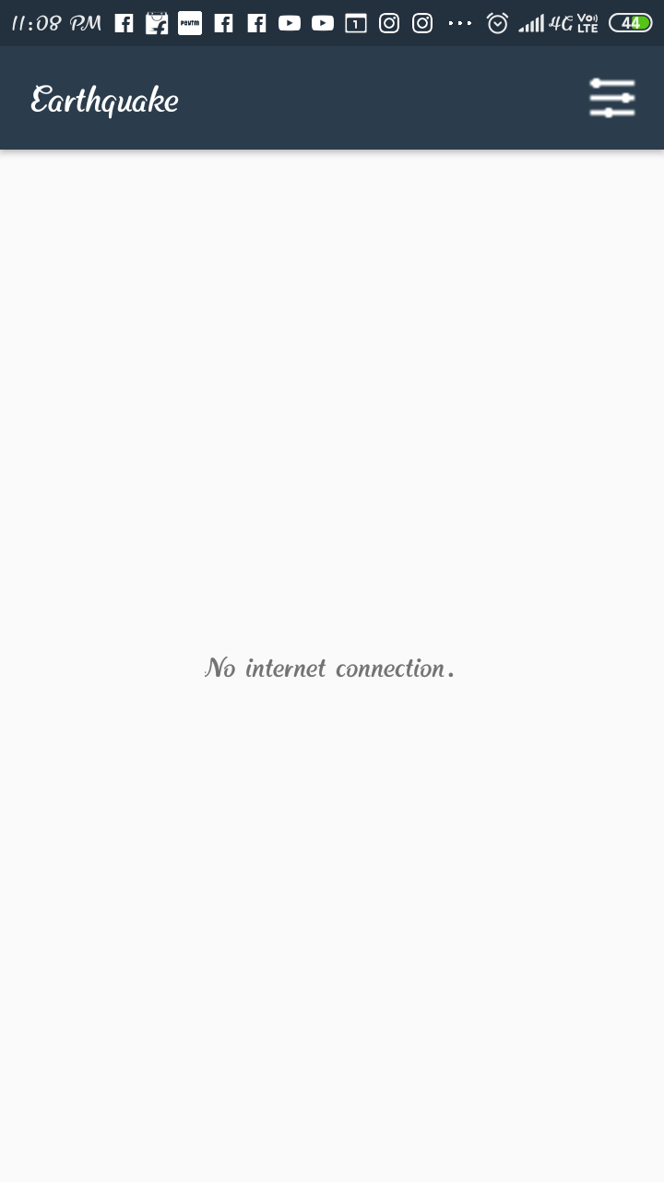

**Preferences :**

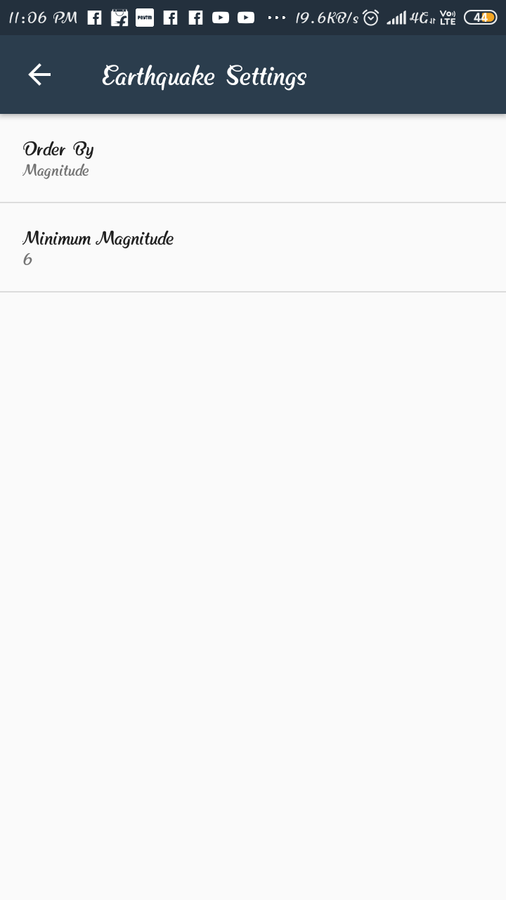

**When order by Magnitude and Minimum magnitude is 6:**

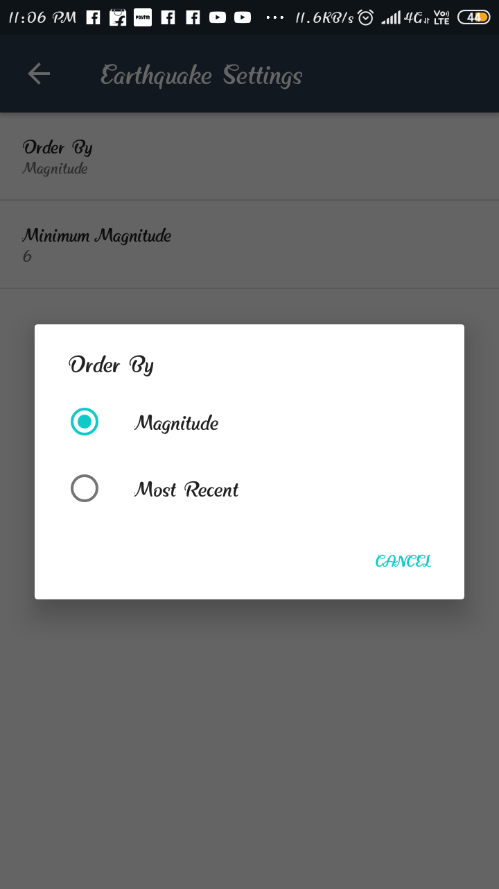

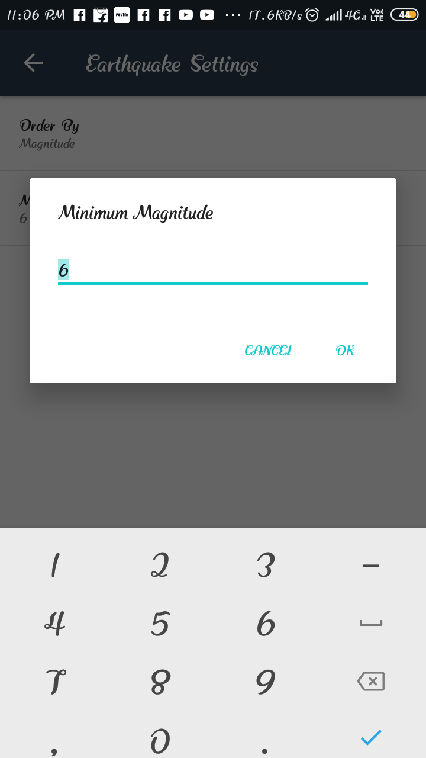

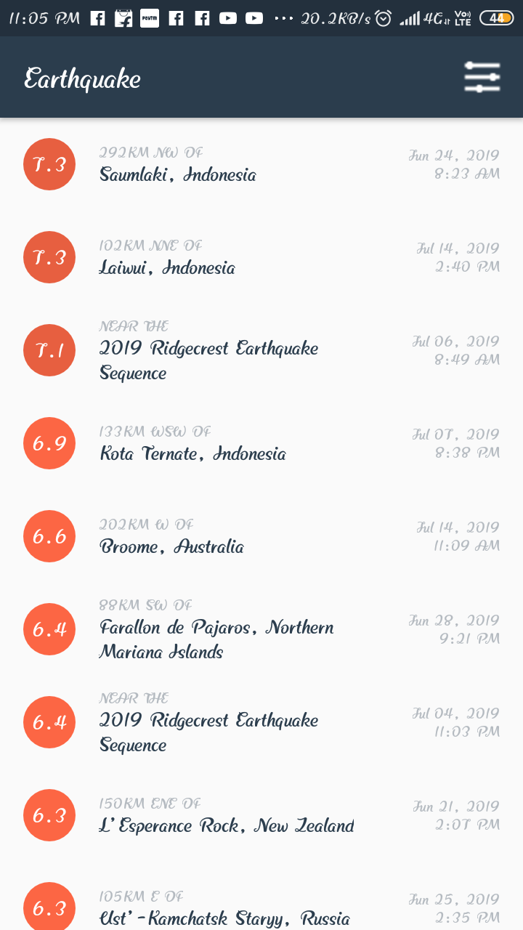

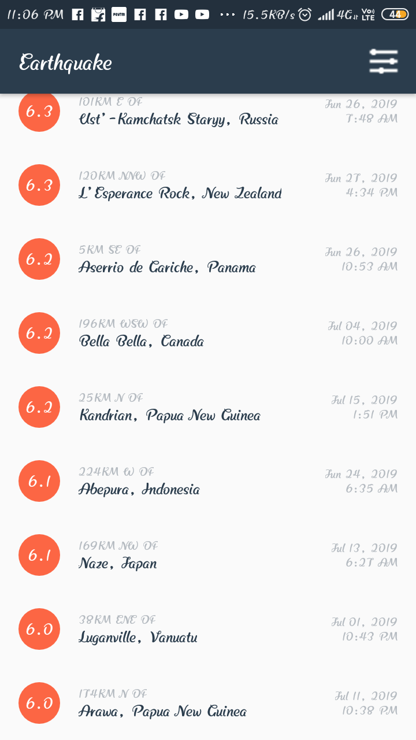

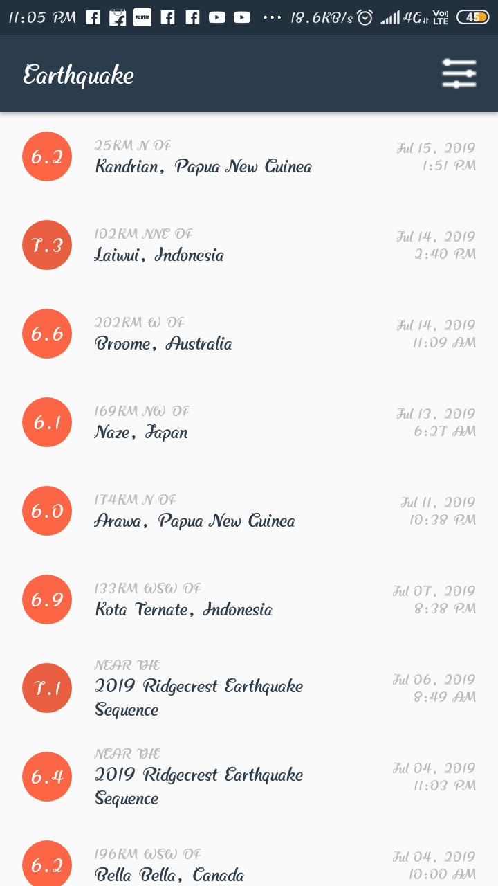

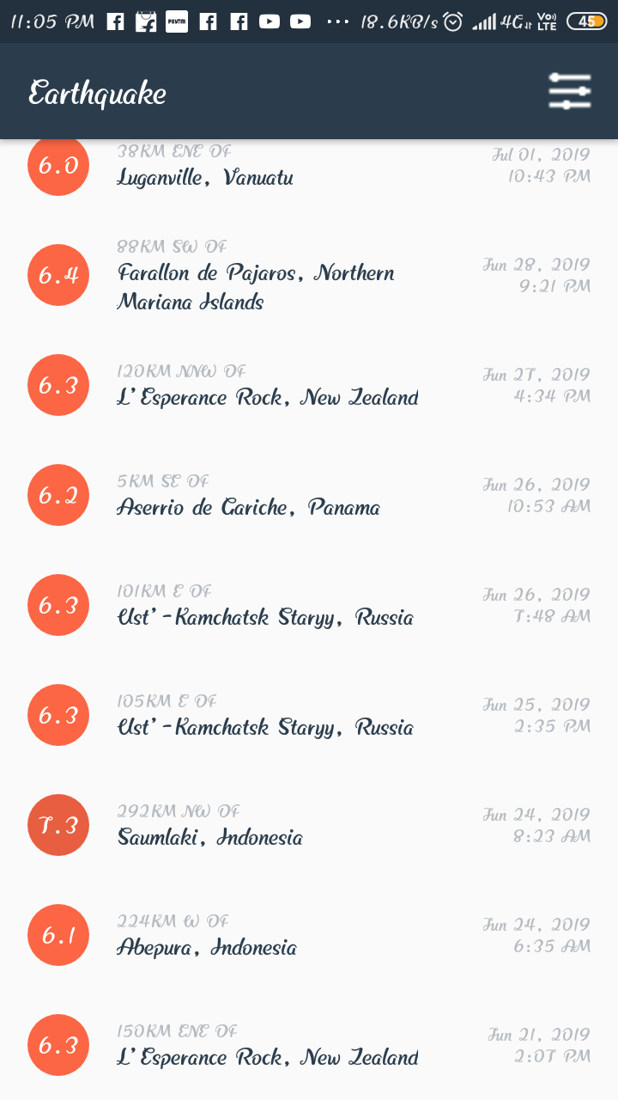

**When Minimum Magnitude is 8:**



# **FUTURE SCOPE OF THE PROJECT**

❖ A further research for development of new technologies in composite construction such

as slim-floor slabs with semi continuous connections to the columns, new steel sheets or

systems to minimize the time of erection and assembly is desirable.

❖ The idealizing assumption of beam-to-column connections as hinged or fully rigid due to

lack of more realistic guidance in view of modeling advocates for further research on

non-linear response of joints considering rotational stiffness, moment of resistance and

rotational capacity. Preparation of guidelines for modeling different type of connections

may also prove very helpful.

❖ Preparation of miniature specimens for testing may be thought of to avoid costly

experimentation generally carried out on full size models to known the exact behavior of

steel-concrete composite structural elements. A numerical analysis of the same will also

be highly desirable to correlate the data and result.

❖ Recent development in composite construction technology, which have successfully

transformed the market place in other countries, providing added value to the customers

and rapid return on the invested capital. These, if adopted in India for residential and

commercial building, could be very beneficial to the Indian community. In this regard,

development of suitable design aids may be very fruitful.

❖ The use of precast concrete and even the prestressed concrete component in certain

composite structure applications may prove fruitful as it has potential due to the economy

that can be achieved by these components in terms of time, labour and money.

❖ More complicated type of truss geometries can be tried. The through type of composite

truss can be attempted with a few modifications in analysis and design procedure.

❖ Some of the GA operators like inversion dominance segregation, deletion, duplication,

etc. which could not be implemented in the present work may be considered.

❖ In the present study the total cost of RCC slab and steel truss were included in the

objective function. However, the cost of the structure can be calculated precisely by

including labour cost, connection cost, stud connection cost and cost of reinforcement in

the objective function which will through light on the effect of each in cost minimization.

# **BIBLIOGRAPHY AND REFERENCES**

BOOK: - Head First Android Development

WEBSITES: -

WWW.ANDROIDHIVE.COM

[WWW.](http://WWW.VBSOURCECODE.COM/)DEVELOPER.ANDROID.COM

SEARCH ENGINES: - YAHOO, MSN, GOOGLE etc.